ISI KANDUNGAN

|  |  |  |
| --- | --- | --- |
| BIL | TAJUK / PERKARA | MUKASURAT |
| 1 | Tujuan | 1 |
| 2 | Maklumat Asas | 1 |
|  | 2.1 Sistem | 1 |
|  | 2.2 Rujukan Projek | 1 |
|  | 2.3 Hubungi | 1 |
| 3 | Kod Sumber  paparan_gym.html | 2-6 |
|  | maklumat_pengguna.php | 7-10 |
|  | daftar.php | 11-12 |
|  | list.php | 13-15 |
|  | edit.php | 16-17 |
|  | delete.php | 18 |

DOKUMENTASI KOD SUMBER BAGI SISTEM *GYMANASTIC*

|  |  |  |
| --- | --- | --- |
| **Versi** | **Tarikh Diluluskan** | **Pemilik** |
| 2 | 9/7/2018 | Nur Sakinah Binti Isnizam |

1. Tujuan

Dokumentasi ini bertujuan sebagai keperluan untuk mengurus kod sumber, memastikan kawalan versi, mengurus dokumen berkaitan dan mengawal risiko kehilangan kod sumber.

1. Maklumat Asas
2. Sistem

|  |
| --- |
| 1. *A software system based on the Windows 7 SmartPhone Platform* 2. *User Medical Referencing System* 3. *System name or title: HOPE* 4. *System code: WP7* 5. Configurasi system 6. Software and hardware requirement 7. Compatibility (kesesuaian penggunaan IDE dengan pembanguna sistem) |

2.2 Rujukan Projek

|  |
| --- |
| Internet   * w3school.com |

2.3 Hubungi

|  |
| --- |
| *Person in charge*  Nur Sakinah - (01126374381) |

1. Kod Sumber

Skrin : paparan_gym.html

Penerangan : Paparan memaparkan Laman Utama,Maklumat Pengguna,Sistem Pengiraan

*Body Index Mass(BMI)*

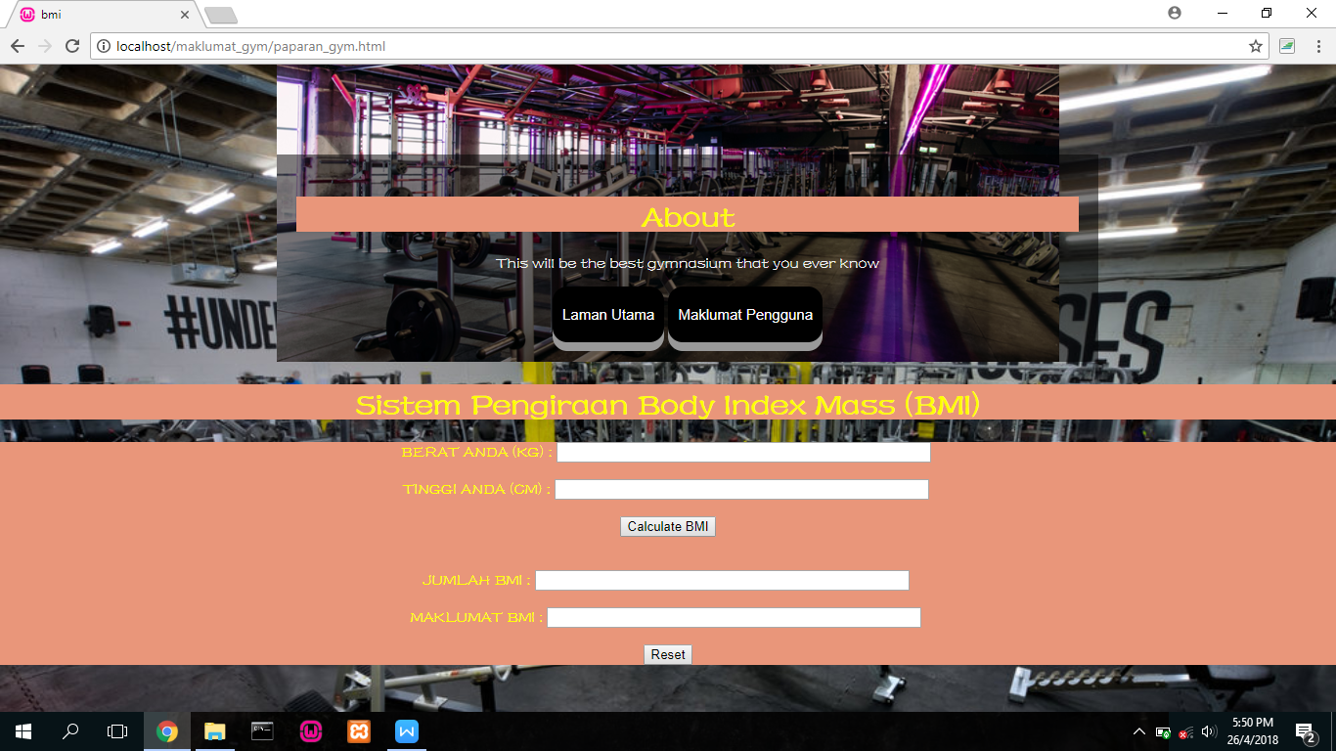

Kod Sumber :

<html>

<style type="text/css">

td

{

padding:2.5px;

border:1px #ccc;

border-style:double;

color:yellow;

}

/* declaration background colour,text align,font family,backgorund image,

background size dan text align */

body {

background-color: plum;

text-align:justify;

font-family:"Fzshuti";

background-image:url("Underground+Gym+Brighton-7.jpg");

background-size:cover;

text-align:center;

}

<head>

<!-- Ini adalah tajuk pada bar tajuk -->

<title> MAKLUMAT GYMNASIUM</title>

</head>

<body>

<center>

<!-- Nama sistem di laman utama -->

<h2> MAKLUMAT GYMNASIUM <br>

</h2>

<html>

<body>

<head>

<meta name="viewport" content="width=device-width, initial-scale=1">

<style>

// declaration untuk bahagian about

* {

box-sizing: border-box;

}

body {

margin: 0;

font-family: Arial;

font-size: 17px;

}

.container {

position: relative;

max-width: 800px;

margin: 0 auto;

}

.container img {vertical-align: middle;}

.container .content {

position: absolute;

bottom: 0;

background: rgba(0, 0, 0, 0.5); /* Black background with transparency */

color: #f1f1f1;

width: 100%;

padding: 20px;

}

</style>

</head>

<body>

<div class="container">

<img src="download (1).jpg" alt="Gymnastic" style="width:100%;">

<!DOCTYPE html>

<html>

<head>

<style>

html {

background: url(download (1).jpg) no-repeat center fixed;

background-size: 500px;

}

body {

color: yellow;

font-family:"Fzshuti";

}

</style>

</head>

<body>

<style>

h1 {

color: yellow;

font-family:"Fzshuti";

}

</style>

</body>

</html>

<div class="content">

<h1>About</h1>

<p>This will be the best gymnasium that you ever know</p>

<html>

<head>

<meta name="viewport" content="width=device-width, initial-scale=1">

<style>

.button {

padding: 20px 10px;

font-size: 15px;

text-align: center;

cursor: pointer;

outline: none;

color: #fff;

background-color: #000000;

border: none;

border-radius: 15px;

box-shadow: 0 9px #999;

}

.button:hover {background-color: #3e8e41}

.button:active {

background-color:;

box-shadow: 0 5px #666;

transform: translateY(4px);

}

body{

color:yellow;

font-family:"Fzshuti";

}

</style>

</head>

<body>

<a href="paparan_gym.html"><button class="button">Laman Utama</button></a>

<a href="maklumat_pengguna.php"><button

class="button">Maklumat Pengguna</button></a>

</body>

</div>

</div>

</body>

</html>

<html>

<head>

<meta charset="utf-8">

<title>bmi</title>

<style>

body {

background-image:url("Underground+Gym+Brighton-7.jpg");

background-size:cover;

text-align:center}

h1,form{

font-style:Fzshuti;

background-color:#E9967A;}

</style>

</head>

<body >

//declaration untuk bahagian pengiraan BMI

<div align="center">

<h1>Sistem Pengiraan Body Index Mass (BMI)</h1>

<script language="JavaScript">

<!--

function calculateBmi() {

var weight = document.bmiForm.weight.value;

var height = document.bmiForm.height.value;

if(weight > 0 && height > 0){

var finalBmi =(weight/((height/100)^2));

document.bmiForm.bmi.value = finalBmi

if(finalBmi < 18){

document.bmiForm.meaning.value = "Terlalu Kurus";

}

if(finalBmi > 18 && finalBmi < 25){

document.bmiForm.meaning.value = "Normal";

}

if(finalBmi > 25){

document.bmiForm.meaning.value = "Berat badan berlebihan";

}

}

else{

alert("Sila masukkan semula berat dan tinggi anda")

}

}

//-->

</script>

<form name="bmiForm">

<TR>

<TD>BERAT ANDA (KG)

<TD>:

<TD colspan="4"><INPUT TYPE="TEXT" name="weight" size="50">

</TR>

<br>

<br>

<TR>

<TD>TINGGI ANDA (CM)

<TD>:

<TD colspan="4"><INPUT TYPE="TEXT" name="height" size="50">

</TR>

<br>

<br>

<input type="button" value="Calculate BMI" onClick="calculateBmi()"><br>

<br>

<br>

<TR>

<TD>JUMLAH BMI

<TD>:

<TD colspan="4"><INPUT TYPE="TEXT" name="bmi" size="50">

</TR>

<br>

<br>

<TR>

<TD>MAKLUMAT BMI

<TD>:

<TD colspan="4"><INPUT TYPE="TEXT" name="meaning" size="50">

</TR>

<br>

<br>

<input type="reset" value="Reset" />

</form>

Skrin : maklumat_pengguna.php

Penerangan : Paparan memaparkan senarai ahli yang telah berdaftar

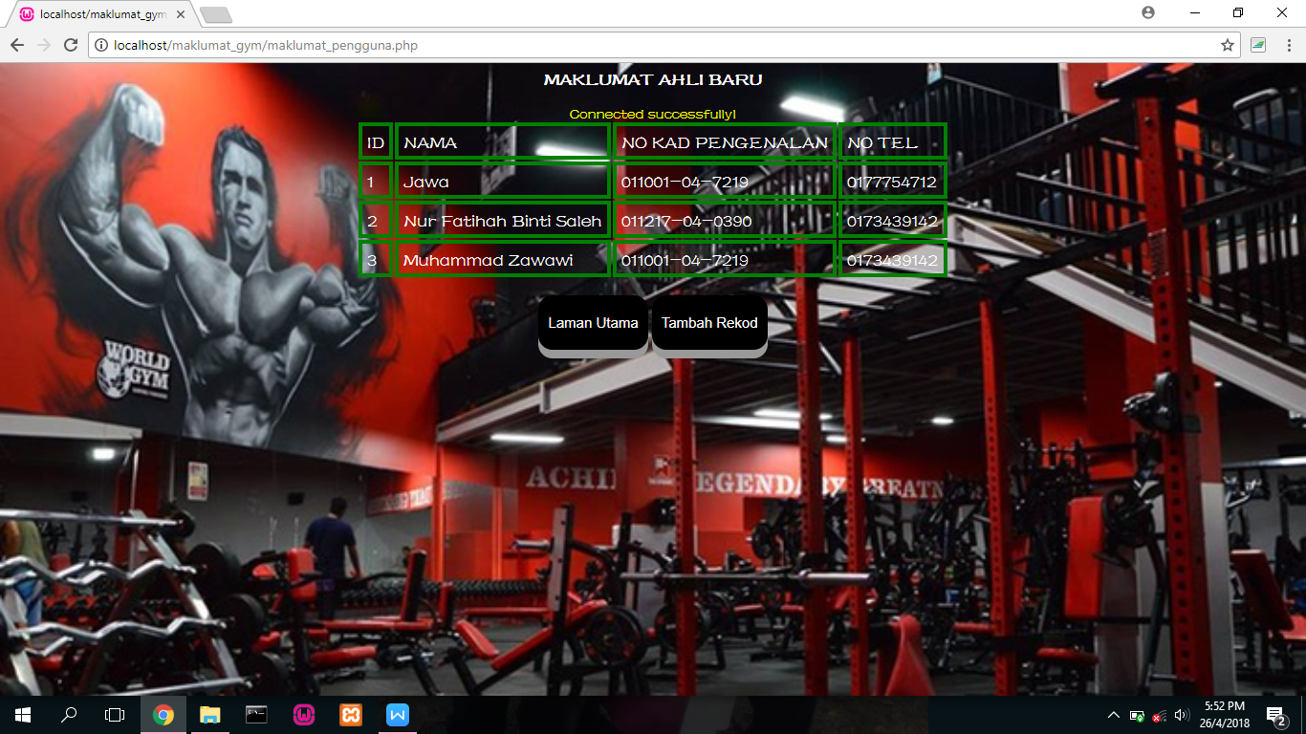

Kod Sumber :

<html>

<style type="text/css">

td

{

padding:5px;

border:4px solid #ccc;

table:blue;

border-style:solid;

border-color:green;

color:white;

font-size:20px;

font-style:bold;

}

// declaration untuk bahgian body jadual

body {

background-color: plum;

text-align:justify;

font-family:"Fzshuti";

background-image:url("download(9).jpg");

background-size:cover;

text-align:center;

}

h2{

color:white;

font-size:20px;

font-style:bold;

}

</style>

<head>

<meta name="viewport" content="width=device-width, initial-scale=1">

<style>

.button {

padding: 20px 10px;

font-size: 15px;

text-align: center;

cursor: pointer;

outline: none;

color: #fff;

background-color: #000000;

border: none;

border-radius: 15px;

box-shadow: 0 9px #999;

}

.button:hover {background-color: #3e8e41}

.button:active {

background-color:;

box-shadow: 0 5px #666;

transform: translateY(4px);

}

* {

box-sizing: border-box;

}

body {

margin: 5;

color: white;

font-family:"Fzshuti";

}

.container {

position: relative;

max-width: 800px;

margin: 0 auto;

}

.container img {vertical-align: middle;}

.container .content {

position: absolute;

bottom: 0;

background: rgba(0, 0, 0, 0.5); /* Black background with transparency */

color: #f1f1f1;

width: 100%;

padding: 20px;

}

</style>

</head>

<body>

<center>

<h2>MAKLUMAT AHLI BARU</h2>

<?php

include('confiq.php');

$query1=mysql_query("select id,nama, no_kp, no_tel from maklumat_gym");

echo "<table>

<tr>

<td>ID</td>

<td>NAMA</td>

<td>NO KAD PENGENALAN</td>

<td>NO TEL</td>";

while($query2=mysql_fetch_array($query1))

{

echo "<tr><td>".$query2['id']."</td>";

echo "<td>".$query2['nama']."</td>";

echo "<td>".$query2['no_kp']."</td>";

echo "<td>".$query2['no_tel']."</td></tr>";

}

?>

</table>

<br>

</center>

</body>

<head>

<meta name="viewport" content="width=device-width, initial-scale=1">

<style>

// declaration button

.button {

padding: 20px 10px;

font-size: 15px;

text-align: center;

cursor: pointer;

outline: none;

color: #fff;

background-color: #000000;

border: none;

border-radius: 15px;

box-shadow: 0 9px #999;

}

.button:hover {background-color: #3e8e41}

.button:active {

background-color:;

box-shadow: 0 5px #666;

transform: translateY(4px);

}

* {

box-sizing: border-box;

}

body {

margin: 5;

color: yellow;

font-family:"Fzshuti";

}

.container {

position: relative;

max-width: 800px;

margin: 0 auto;

}

.container img {vertical-align: middle;}

.container .content {

position: absolute;

bottom: 0;

background: rgba(0, 0, 0, 0.5); /* Black background with transparency */

color: #f1f1f1;

width: 100%;

padding: 20px;

}

</style>

</head>

// declaration untuk link ke laman utama dan tambah rekod

<a href="paparan_gym.html"><button class="button">Laman Utama</button></a>

<a href="daftar.php"><button class="button">Tambah Rekod</button></a>

</html>

Skrin : daftar.php

Penerangan : Paparan memaparkan maklumat yang diperlukan ketika ingin menambah nama ahli baru

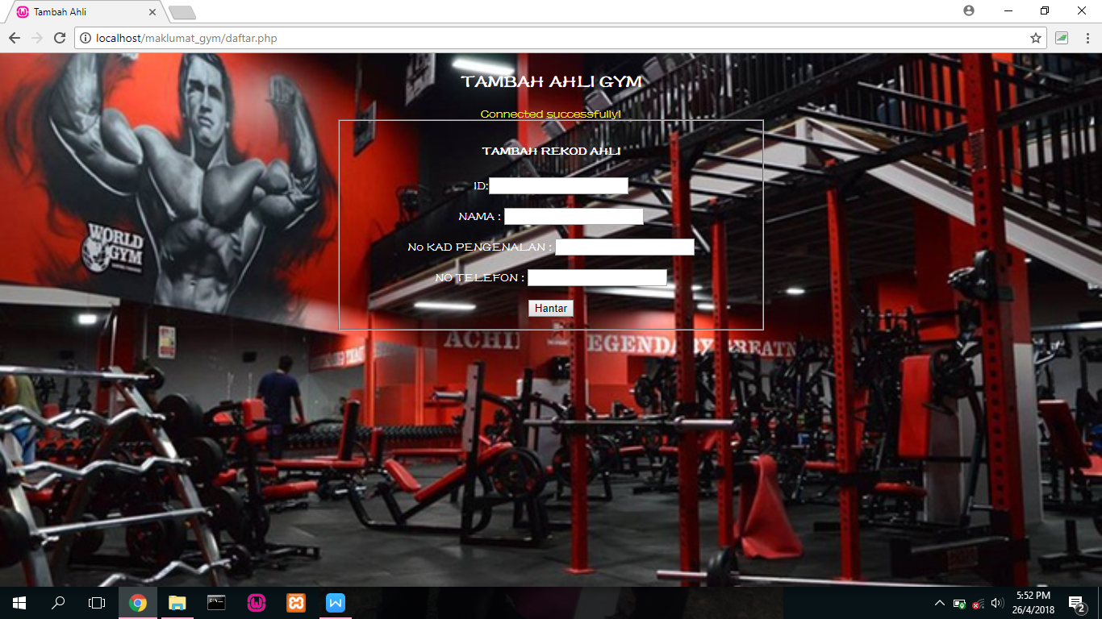

Kod Sumber :

<!DOCTYPE html>

<html>

<head>

<style>

html {

// declaration untuk bahagian background

background: url("download(9).jpg") no-repeat center fixed;

background-size: cover;

}

//declaration tulisan dalam kotak

form {

color: white;

padding:5px;

}

h2{

color:white;

}

h4{

color:white;

}

//declaration untuk margin,color dan font

body {

margin: 5;

color: yellow;

font-family:"Fzshuti";

}

</style>

<!-- Ini adalah tajuk pada bar tajuk -->

<title> Tambah Ahli</title>

<center>

<!-- Nama sistem di laman utama -->

<h2>TAMBAH AHLI GYM</h2>

<?php

include('confiq.php');

if(isset($_POST['submit']))

{

$id=mysql_real_escape_string($_POST['id']);

$nama=mysql_real_escape_string($_POST['nama']);

$no_kp=mysql_real_escape_string($_POST['no_kp']);

$no_tel=mysql_real_escape_string($_POST['no_tel']);

$query1=mysql_query("insert into

maklumat_gym values('$id','$nama','$no_kp','$no_tel')");

echo "insert into maklumat_gym values('$id','$nama','$no_kp','$no_tel')";

if ($query1)

{

header("location:list.php");

}

}

?>

<center>

<fieldset style="width:500px;">

<h4>TAMBAH REKOD AHLI</h4>

<form method="post" action="">

ID:<input type="text" name="id"><br>

<br>

NAMA : <input type="text" name="nama"><br>

<br>

No KAD PENGENALAN : <input type="text" name="no_kp"><br>

<br>

NO TELEFON : <input type="text" name="no_tel"><br>

<br>

<input type="submit" name="submit" value="Hantar"><a href = 'list.php'></a>

</form>

</fieldset>

</center>

</body>

</html>

Skrin : list.php

Penerangan : Paparan memaparkan maklumat yang ahli yang telah berdaftar dan mempunyai perkara yang diperlukan seperti kemaskini dan memadam maklumat ahli

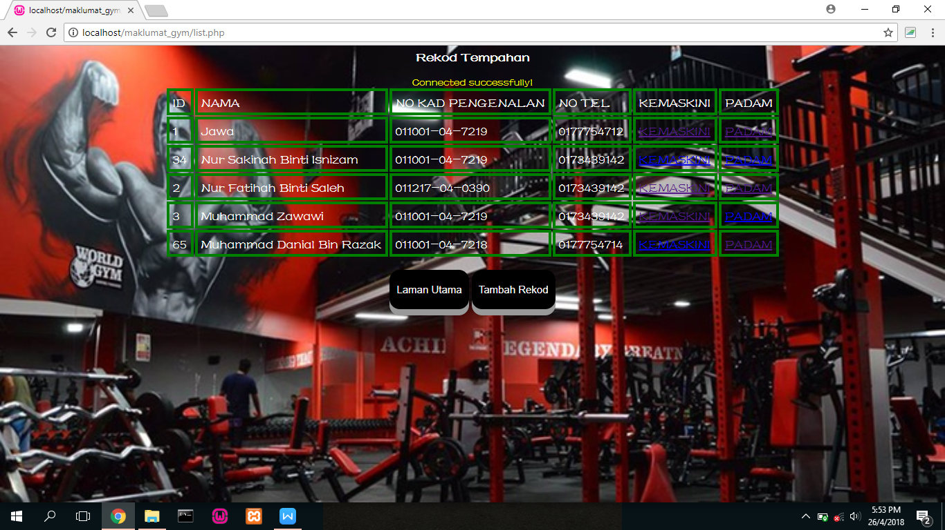

Kod Sumber :

<html>

<style type="text/css">

// declaration untuk jadual

td

{

padding:5px;

border:4px solid #ccc;

table:blue;

border-style:solid;

border-color:green;

color:white;

font-size:20px;

font-style:bold;

}

body {

background-color: plum;

text-align:justify;

font-family:"Fzshuti";

background-image:url("download(9).jpg");

background-size:cover;

text-align:center;

}

// declaration untuk tulisan

h2{

color:white;

font-size:20px;

font-style:bold;

}

</style>

</style>

<body>

<center>

<h2>Rekod Tempahan</h2>

<?php

include('confiq.php');

$query1=mysql_query("select id,nama, no_kp, no_tel from maklumat_gym");

echo "<table>

<tr>

<td>ID</td>

<td>NAMA</td>

<td>NO KAD PENGENALAN</td>

<td>NO TEL</td>

<td>KEMASKINI</td>

<td>PADAM</td>";

while($query2=mysql_fetch_array($query1))

{

echo "<tr><td>".$query2['id']."</td>";

echo "<td>".$query2['nama']."</td>";

echo "<td>".$query2['no_kp']."</td>";

echo "<td>".$query2['no_tel']."</td>";

echo "<td><a href='edit.php?id=".$query2['id']."'>KEMASKINI</a></td>";

echo "<td><a

href='delete.php?id=".$query2['id']."'>PADAM</a></td></tr>";

}

?>

</table>

<br>

<head>

<meta name="viewport" content="width=device-width, initial-scale=1">

<style>

// declaration untuk button

.button {

padding: 20px 10px;

font-size: 15px;

text-align: center;

cursor: pointer;

outline: none;

color: #fff;

background-color: #000000;

border: none;

border-radius: 15px;

box-shadow: 0 9px #999;

}

.button:hover {background-color: #3e8e41}

.button:active {

background-color:;

box-shadow: 0 5px #666;

transform: translateY(4px);

}

* {

box-sizing: border-box;

}

body {

margin: 5;

color: yellow;

font-family:"Fzshuti";

}

.container {

position: relative;

max-width: 800px;

margin: 0 auto;

}

.container img {vertical-align: middle;}

.container .content {

position: absolute;

bottom: 0;

background: rgba(0, 0, 0, 0.5); /* Black background with transparency */

color: #f1f1f1;

width: 100%;

padding: 20px;

}

</style>

</head>

<a href="paparan_gym.html"><button class="button">Laman Utama</button></a>

<a href="daftar.php"><button class="button">Tambah Rekod</button></a>

</center>

</body>

</html>

Skrin : edit.php

Penerangan : Paparan memaparkan maklumat ahli yang ingin dikemaskini

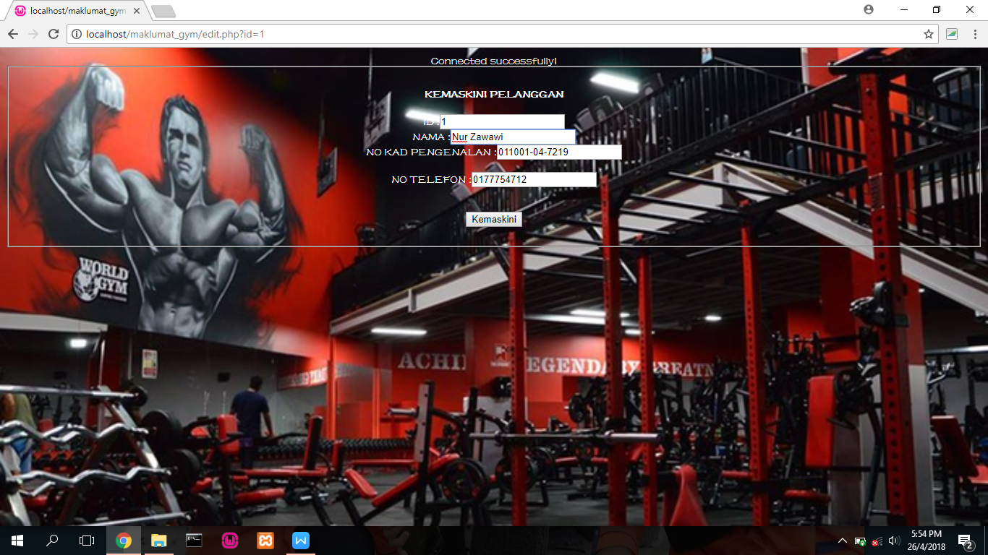

Kod Sumber :

<html>

<style type="text/css">

td

{

padding:5px;

border:1px solid #ccc;

border-style:double;

color:white;

}

//declaration untuk gambar dan tulisan

body {

background-color: plum;

text-align:justify;

font-family:"Fzshuti";

background-image:url("download(9).jpg");

background-size:cover;

text-align:center;

}

</style>

<body>

<?php

include('confiq.php');

if(isset($_GET['id']))

{

$id=$_GET['id'];

if(isset($_POST['submit']))

{

$id=$_POST['id'];

$nama=$_POST['nama'];

$no_kp=$_POST['no_kp'];

$no_tel=$_POST['no_tel'];

$query3=mysql_query("update

maklumat_gym set id='$id',nama='$nama',no_kp='$no_kp'

,no_tel='$no_tel' where id='$id'");

if($query3)

{

header('location: list.php');

}

}

$query1=mysql_query("select * from maklumat_gym where id='$id'");

$query2=mysql_fetch_array($query1);

?>

<center>

<style>

body{

color:white;

font-family:"Fzshuti";

}

</style>

<fieldset style="witdh:500px;">

// declaration untuk maklumat kemaskini

<h4>KEMASKINI PELANGGAN</h4>

<form method="post" action="">

ID :<input type="text" name="id" value="<?php echo

$query2['id']; ?>"><br>

NAMA :<input type="text" name="nama" value="<?php echo

$query2['nama']; ?>"><br>

NO KAD PENGENALAN :<input type="text" name="no_kp" value="<?php echo

$query2['no_kp']; ?>"><br><br>

NO TELEFON :<input type="text" name="no_tel" value="<?php echo

$query2['no_tel']; ?>"><br><br>

<br>

// button untuk kemaskini

<input type="submit" name="submit" value="Kemaskini">

</form>

<?php

}

?>

</fieldset>

</center>

</body>

</html>

</html>

Skrin : delete.php

Penerangan : Paparan memaparkan maklumat yang ahli yang telah dipadam

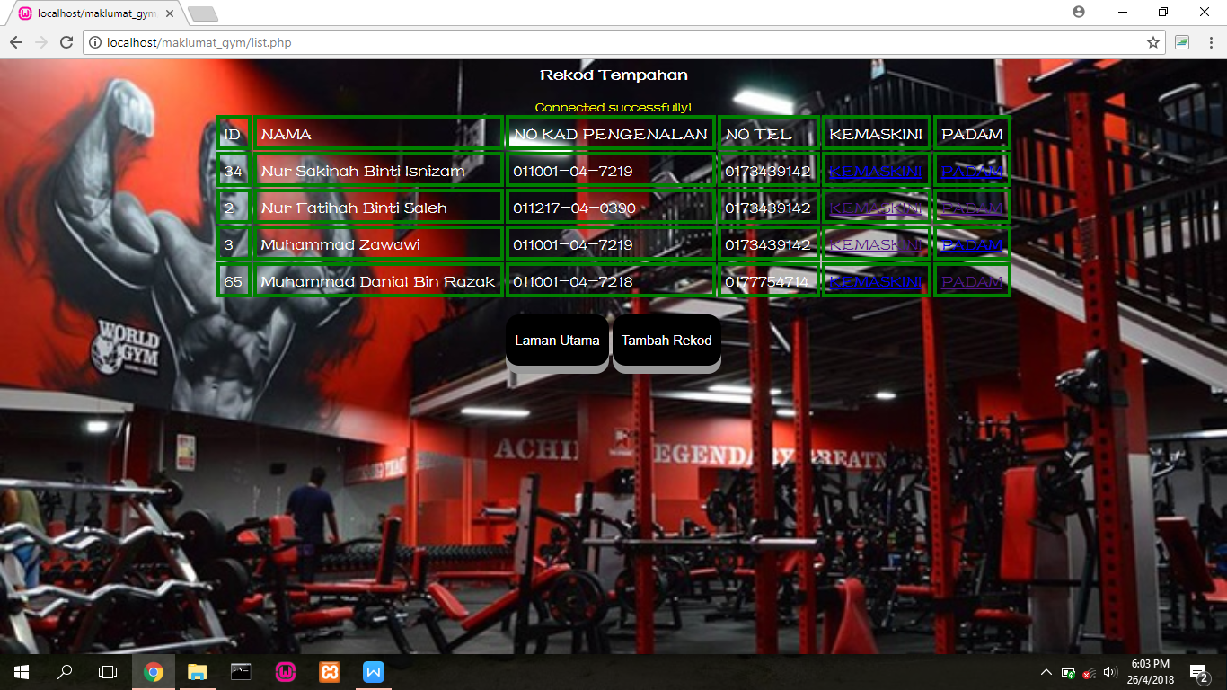

Kod Sumber :

<html>

<body>

<?php

include('confiq.php');

if(isset($_GET['id']))

{

$id=$_GET['id'];

$query1=mysql_query("delete from maklumat_gym where id='$id'");

if($query1)

{

// location untuk memadam list

header('location:list.php');

}

}

?>

</body>

</html>